WEEK 5 INTERNSHIP REPORT
Deployment Planning, Ethical Considerations, and Reflective Analysis
Student Academic Risk Prediction
Virtual Machine Learning Implementation Intern

Project Detail | Information
Internship Week | Week 5 – Final Week
Project | Student Academic Risk Prediction
Programming Language | Python
Machine Learning Task | Three-class classification
Target Classes | Dropout, Enrolled, Graduate
Dataset | UCI – Predict Students' Dropout and Academic Success
Project Focus | Early academic-risk prediction

1. Introduction
This report is the final week document for my Student Academic Risk Prediction project. The project uses machine learning to predict whether a student is likely to be classified as Dropout, Enrolled, or Graduate. During the internship, I worked through the project step by step, starting with planning and understanding the problem, then exploring algorithms, testing models, evaluating their performance, and organizing the code structure. In Week 5, I focused on what would be needed if the model were taken from a project environment into a real application.
The deployment plan in this report is a proposed plan rather than a claim that the model has already been deployed in production. It covers the application flow, infrastructure, maintenance, scalability, security, ethical issues, possible deployment risks, and a contingency plan. I have also included a reflection on the work completed during the internship and the improvements I would consider if I continue the project.

2. Proposed Deployment Strategy
A practical way to deploy the project would be to save the trained machine learning pipeline and connect it to a small Python web application. An authorised user such as a teacher or institutional staff member could enter the required student information through a web interface. The application would validate the input, apply the same preprocessing used during model training, pass the processed record to the saved model, and display the predicted class.
- Save the trained preprocessing and model pipeline so the same transformations are used during prediction.
- Create a backend service in Python to receive validated student information and return the prediction.
- Provide a simple web interface for authorised users to enter or upload student data.
- Add input validation so incomplete or incorrectly formatted records are rejected before prediction.
- Keep prediction logs and system logs separate from unnecessary personal information.
- Use authentication and access permissions before allowing users to submit student records.
- Monitor model performance and application errors after deployment.
- Review and retrain the model when the available data or student population changes significantly.

3. Proposed Deployment Architecture
The proposed architecture below shows one possible route from student data to the final prediction. The trained model is treated as one component inside a larger application rather than as a standalone script.
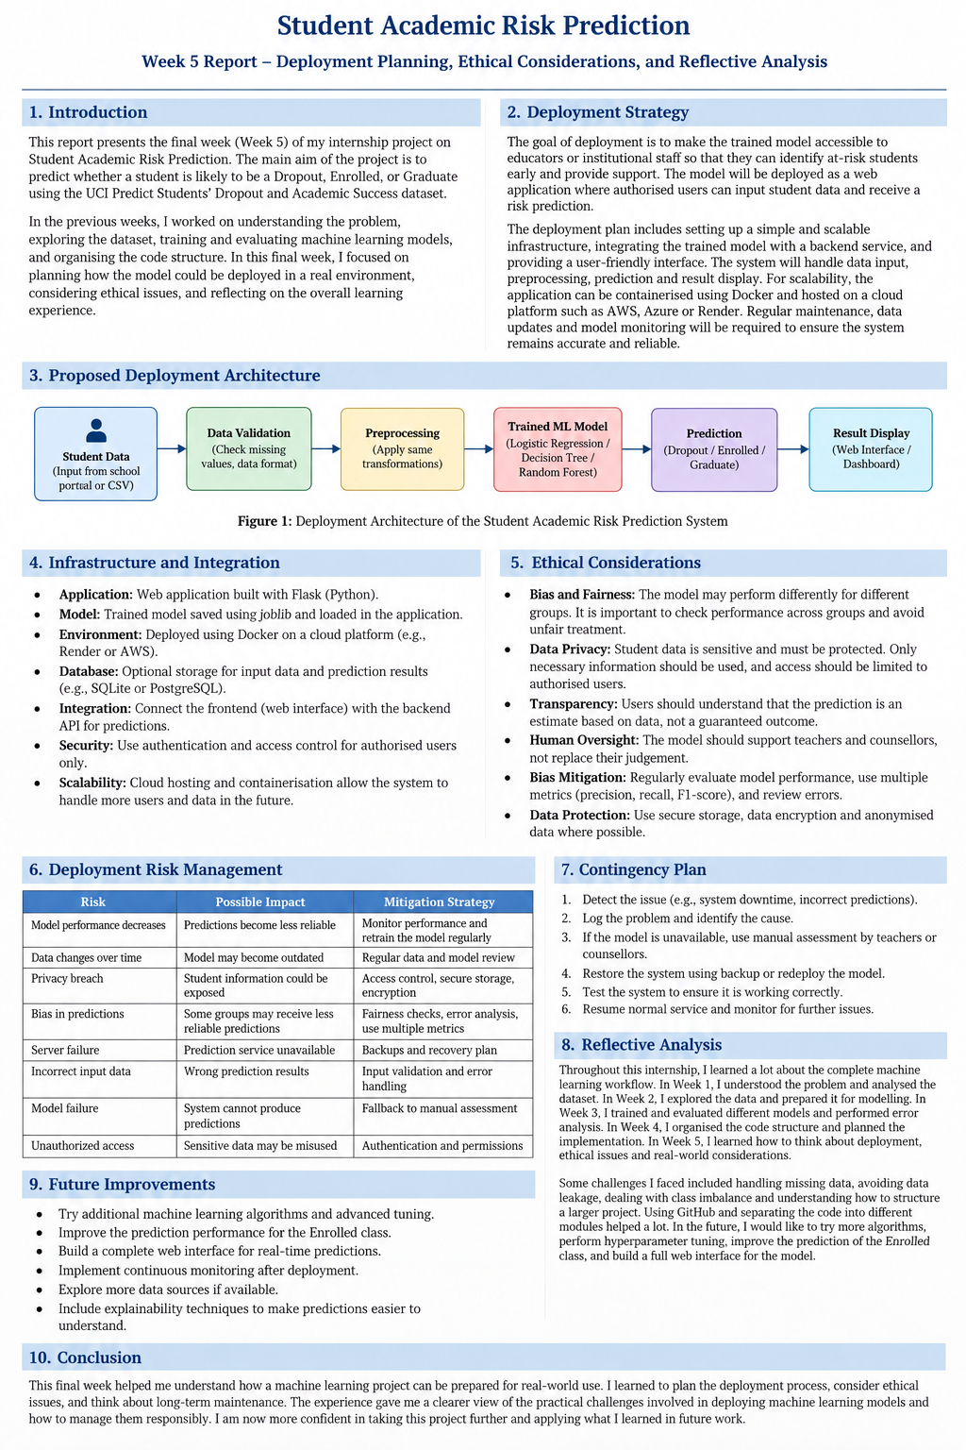
Figure 1. Proposed deployment architecture for the Student Academic Risk Prediction system.

4. Infrastructure and Integration Plan
Component | Proposed Role
Web interface | Allows an authorised user to enter student information or provide a supported data file.
Backend/API | Receives requests, validates input, loads the model and returns the prediction.
Preprocessing pipeline | Applies the same encoding and scaling used during model development.
Saved ML model | Produces the predicted class: Dropout, Enrolled, or Graduate.
Database/storage (optional) | Can store approved records and prediction information when required.
Container/cloud environment | Can package and host the application and its dependencies.
Monitoring/logging | Tracks application failures, response problems and model performance indicators.

For a small initial deployment, the system could run on a basic server or cloud instance. If usage increases, the application can be containerised and moved to a cloud platform. The important point is that the deployment environment should use the same Python and package versions that were tested during development. The model, preprocessing steps, and application code should be versioned so that a previous working version can be restored if a new release causes problems.

5. Scalability, Maintenance, and Efficiency
- Keep the prediction service separate from training. Training can be performed offline while the deployed service only performs prediction.
- Load the trained model when the application starts instead of loading it for every individual request.
- Validate input before running the model to avoid unnecessary processing and confusing errors.
- Use a simple database only when storing prediction records is actually required.
- For more users, run multiple application instances behind a suitable service or load-balancing setup.
- Monitor response time, failed requests, input errors, and model performance indicators.
- Schedule periodic reviews of the model rather than assuming that its performance will remain constant forever.
- Keep backups of the model and important configuration so the previous version can be restored.

6. Ethical Considerations

6.1 Bias and Fairness
A prediction model can learn patterns from the data it receives, including patterns that may not be fair for every student group. A model should therefore not be treated as a final judgement about a student's future. Performance should be checked using more than overall accuracy, and errors should be reviewed regularly. Where relevant and legally appropriate, performance can also be compared across groups to identify large differences.

6.2 Data Privacy
Student academic information should be handled carefully because it can contain personal and educational information. Only information that is needed for the prediction should be collected. Access should be limited to authorised users, and stored data should be protected. If possible, development and testing should use anonymised or de-identified records rather than identifiable student information.

6.3 Transparency
Users should know that the system gives a machine learning prediction and not a guaranteed result. The prediction should be presented with suitable context so that teachers or counsellors understand its limitations. If an explanation method is added later, it can help users understand which inputs influenced a prediction.

6.4 Human Oversight
The system should support academic staff rather than automatically deciding important actions for students. A prediction could be used as an early warning signal that encourages a teacher or counsellor to look at a student's situation more carefully. Final decisions should consider information that may not be available to the model.

7. Bias Mitigation and Responsible Use
- Use class-level precision, recall, and F1-score instead of depending only on accuracy.
- Review confusion matrices and identify classes that are frequently misclassified.
- Check whether model performance changes substantially across relevant groups when suitable data is available.
- Compare model versions before replacing a deployed model.
- Keep a human review step for high-impact academic decisions.
- Document the dataset, feature definitions, training process, limitations, and model version.
- Avoid collecting or exposing personal information that is not necessary for the intended prediction.

8. Deployment Risk Management
Risk | Possible Impact | Mitigation / Response
Model performance decreases | Predictions become less reliable. | Monitor performance, review errors, and retrain or replace the model when justified.
Data distribution changes | The model may not work as well on new student data. | Monitor input patterns and schedule periodic model reviews.
Incorrect input data | The application may return a misleading prediction. | Validate fields, ranges, formats, and required inputs before prediction.
Privacy breach | Student information could be exposed. | Use authentication, permissions, secure storage, and minimise collected data.
Bias or unfair performance | Some groups may receive less reliable predictions. | Perform fairness checks, compare metrics, and keep human oversight.
Server/application failure | Users cannot obtain predictions. | Keep backups and provide a manual assessment fallback.
Dependency conflict | The application may fail after an update. | Pin/test dependencies and keep a known working environment.
Model file corruption | The prediction service may not load the model. | Maintain versioned backups and verify model files before release.
Unauthorised access | The system could be misused. | Use authentication, role-based permissions, and security monitoring.

9. Contingency Plan
If the deployed system stops working or starts producing unreliable results, the following response can be used:
- Identify and record the problem, such as application downtime, invalid inputs, or unusual model results.
- Temporarily stop automated predictions if there is a reason to believe the output is unreliable.
- Use manual assessment by the responsible academic staff while the problem is investigated.
- Check application logs, recent code changes, dependencies, input data, and the model version.
- Restore the last known working version if the problem was caused by a recent deployment.
- Test the restored or corrected system with known test cases before making it available again.
- Document the cause and solution so the same problem is easier to handle in the future.

10. Reflective Analysis
Looking back at the internship, I learned the project in stages instead of trying to complete everything at once. In Week 1, I worked on understanding the problem, setting the project goals, and planning the approach. In Week 2, I studied different machine learning algorithms and compared them before deciding what to use. Week 3 was more practical because I designed the experiment, used cross-validation, evaluated the models, and looked at where the predictions were going wrong. In Week 4, I concentrated on the structure of the project and how the Python files could be kept separate and easier to maintain. Finally, in Week 5, I looked beyond the model itself and thought about deployment, privacy, fairness, and what could happen when the system is used outside the development environment.
One thing that worked well for me was keeping the project organised by weeks and using GitHub to save the work. It made it easier to see what had been completed and gave me a backup of the project. Another useful part was checking model errors instead of looking only at the accuracy number. The Week 3 experiment showed that the Enrolled class was harder for the models to predict, which is something I would want to improve in future work.
I also faced some practical difficulties while working on the project. Setting up the Python environment and getting the required libraries to work correctly took some effort. I also had to pay attention to the difference between using all available dataset features and using only information that would really be available for an early prediction. Organising the code into separate files and keeping the results in the correct folders also became important as the project grew.
If I continue this project, I would like to test more algorithms, perform hyperparameter tuning, improve the prediction of the Enrolled class, and build a simple interface for making predictions. I would also like to add better monitoring and model explanation so that the system is easier for an actual user to understand.

11. Future Improvements
- Test additional classification algorithms and compare them using the same evaluation procedure.
- Perform hyperparameter tuning and compare tuned models with the current models.
- Improve performance on the Enrolled class through better feature analysis and suitable class-balancing methods.
- Create a simple web interface for authorised users.
- Save and version the trained model and preprocessing pipeline for repeatable deployment.
- Add model monitoring and periodic retraining when new data becomes available.
- Add explainability methods so users can better understand model predictions.
- Carry out a more detailed fairness assessment before any real-world use.

12. Conclusion
Week 5 brought the project beyond model training and into the practical questions that come with using a machine learning system in a real setting. I prepared a deployment plan covering the application flow, infrastructure, maintenance, scalability, efficiency, and recovery steps. I also considered ethical issues such as bias, fairness, privacy, transparency, and the need for human oversight. The reflection helped me look at the complete internship and understand how each week contributed to the final project. The current system is a project and deployment plan, not a production service, but the proposed structure gives a clear direction for taking it further.

13. References
- UCI Machine Learning Repository. Predict Students' Dropout and Academic Success dataset.
- Python Software Foundation. Python documentation.
- scikit-learn documentation. Machine learning and model evaluation tools.
- pandas documentation. Data analysis and manipulation in Python.

